

NAME: Steed Mbugua
ADM NO: BSCCS/2024/54025
COURSE: BACHELOR OF SCIENCE IN COMPUTER SCIENCE.
UNIT TITLE: BIT 3208.
UNIT NAME :Advanced Web Design And Development
LECTURER : MR. MICHAEL NYORO.
SEMESTER:(Year III, Sem II)

PROJECT DETAILS

Project title: PIVOT HOME
Selected Technologies
Backend: PHP,MySQL,MySQLi,Apache
Frontend: HTML,CSS,Javascript

Online Portfolio / GitHub Link

https://github.com/5star360/furniture-store

TABLE OF CONTENTS
Week 1: Local Environment Setup 3
Installation and Testing of Local Development Environment……………………….

Week 2: Wireframes and GUI Design 6
Dashboard layout……………………………………………………………..

Week 3: JavaScript and PHP Basics 9
Form Validation……………………………………………………………………………………………

Week 4: Server-Side Components and Backend Development 12
Database Connection………………………………………………………………………………………

Week 5:Introduction to Modern Backend 15
CRUD Operations……………………………………………………………………………………………..

Week 1: Local Environment Setup
TITLE
Installation and Testing of Local Development Environment
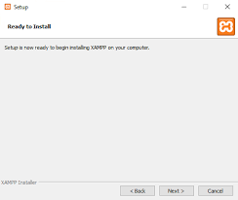
Fig 1: XAMPP Installation.
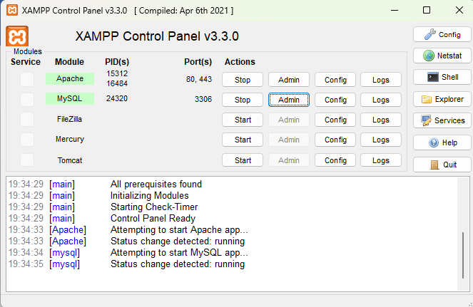
Fig 2: Apache and MySQL Running.
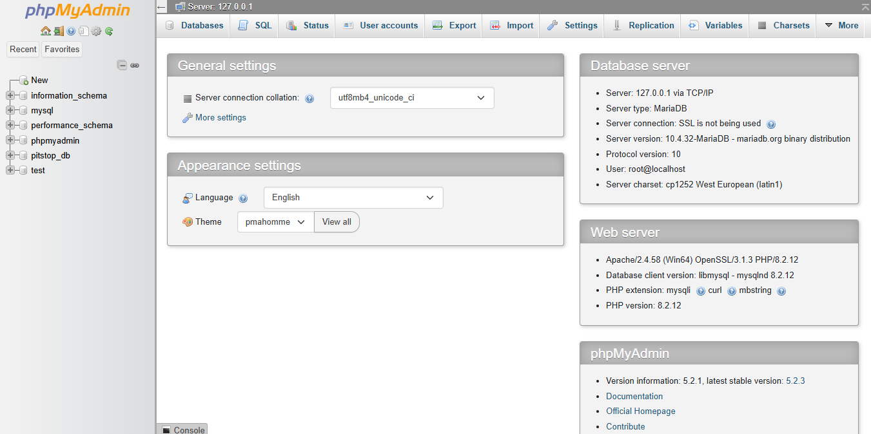
Fig 3: XAMPP Dashboard Page.

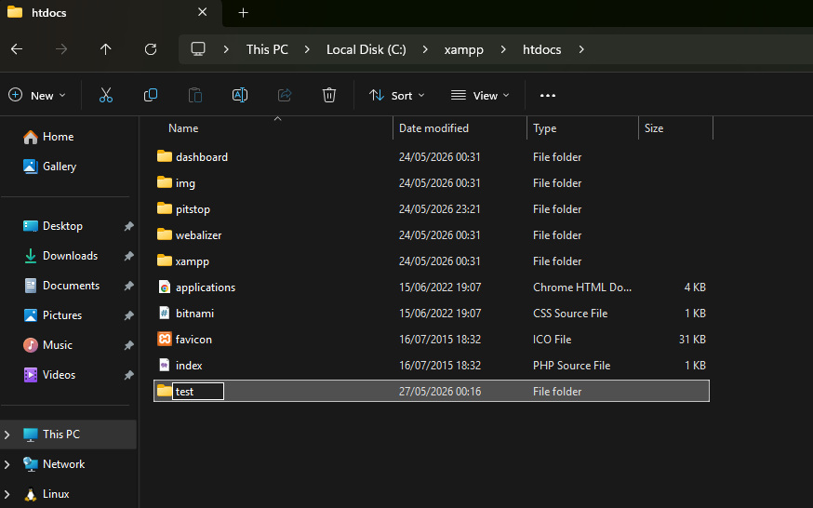
Fig 4: Test folder inside XAMPP htdocs folder.

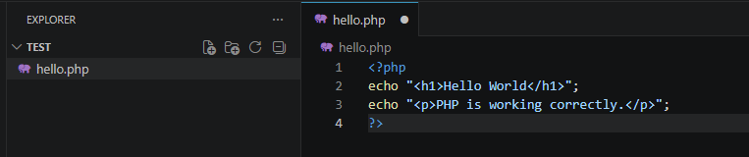
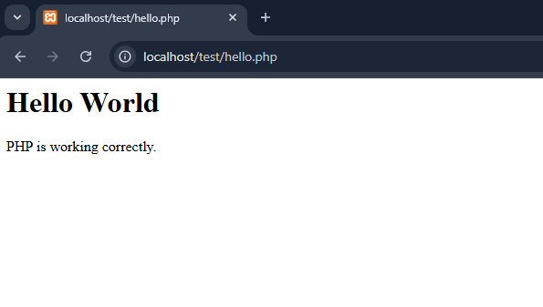
Fig 5: First PHP Page.
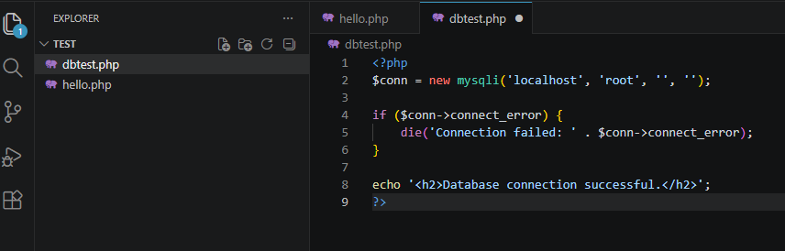

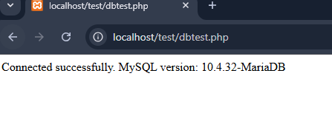
Fig 6: Successful Database Connection.

MY REFLECTION (Week1)
I learnt how to connect a system to a database .I used technologies such as PHP ,MySQL , XAMPP, HTML,CSS and Java script . Some of the issues I encountered are When one logs in it was taking you to a blank white page but I later found out I was being redirected to a page that didn’t exist.
The screenshots demonstrate: Fig 1 -Successful XAMPP Installation. Fig 2 - Apache and MySQL running .Fig 3 - XAMPP Dashboard running on http://localhost/.Fig 4&5 -Test page file inside XAMPP htdocs folder and first successful PHP page. Fig 6 - Successful database connection.

Week 2: Wireframes and GUI Design

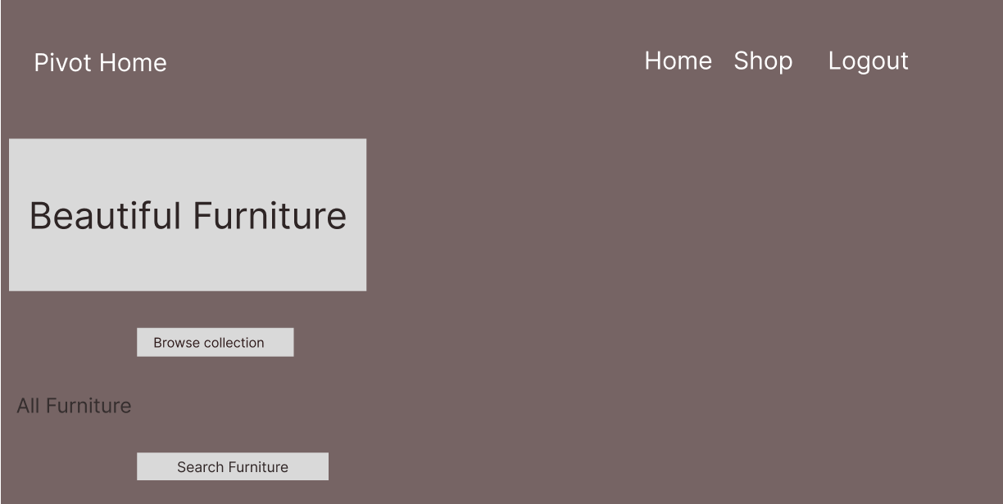
Fig 1: Wireframe showcasing nav bar shop now
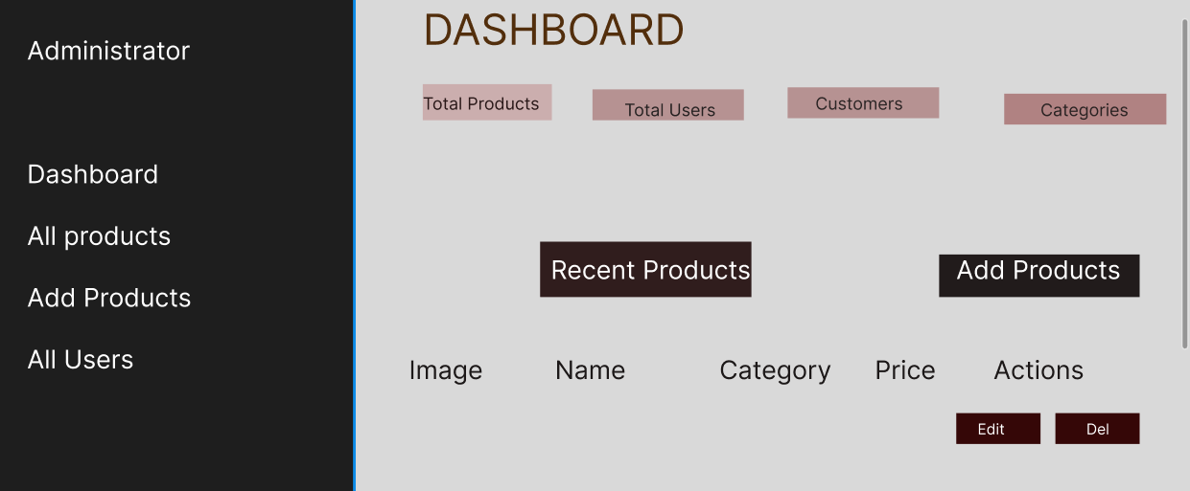.
Fig 2: Dashboard layout design
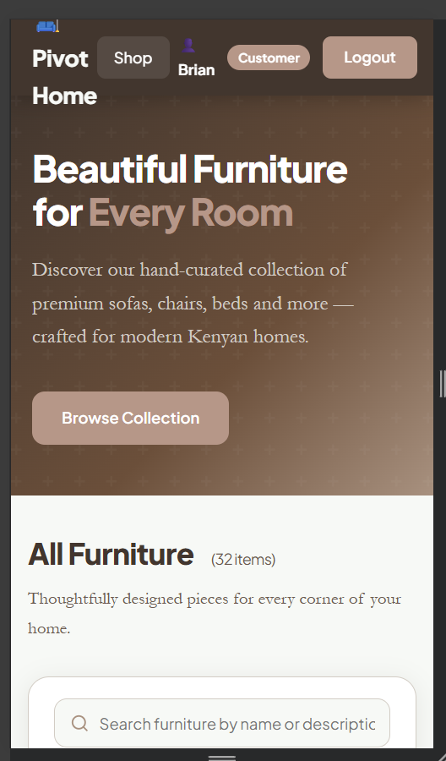

Fig 3: Mobile View Mockup

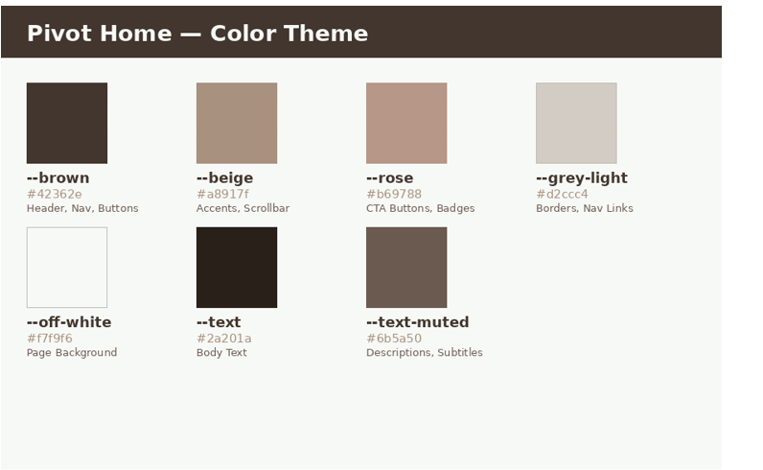

Fig 4: Color Theme


Fig 5: GUI Prototype in Figma

My reflection (Week 2)

I chose the design since it was really beautiful and it shows the nature of raw materials used in the designing of furniture. I considered user experience by making it simple to navigate through and adding a search bar to find items easily and also put them into categories.

The navigation flow is such that customers can login and later logout while the admin has his own dashboard. The intended system users are the admin, guests and customers

Week 3: JavaScript and PHP Basics

Frontend Interaction and Backend Foundations

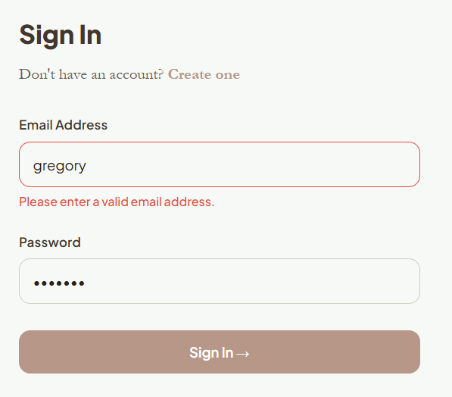

Fig 1: JavaScript Form Validation

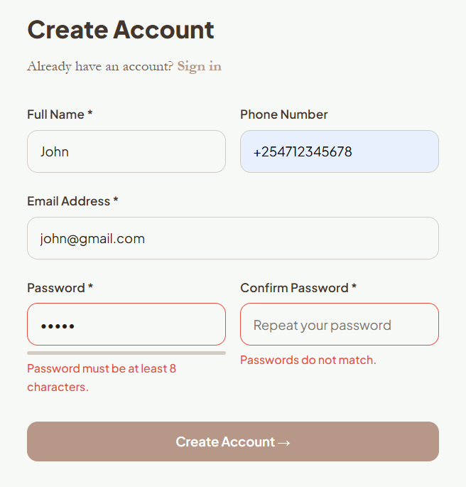

Fig 2: Password Strength Checker

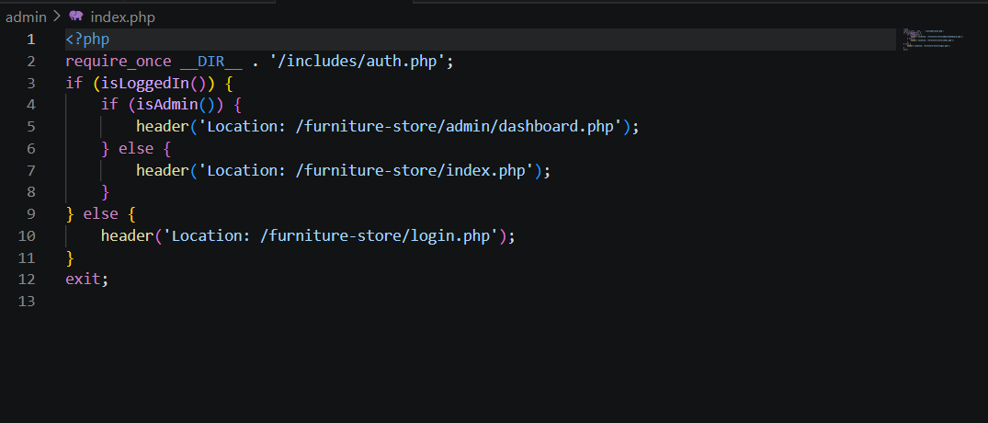

Fig 3: PHP Syntax Practice

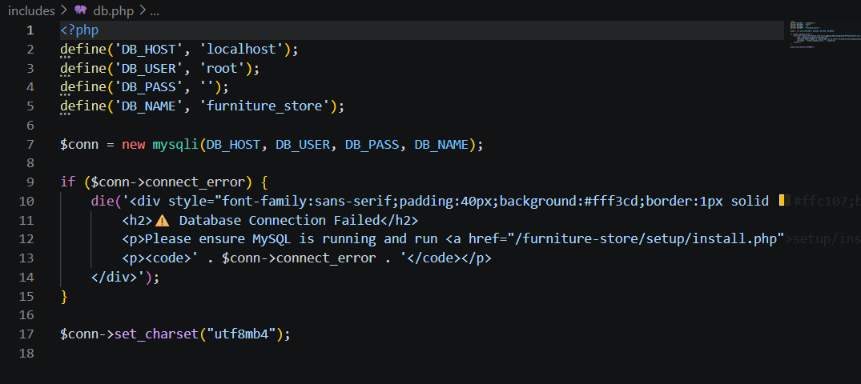

Fig 4: Database Connection Script

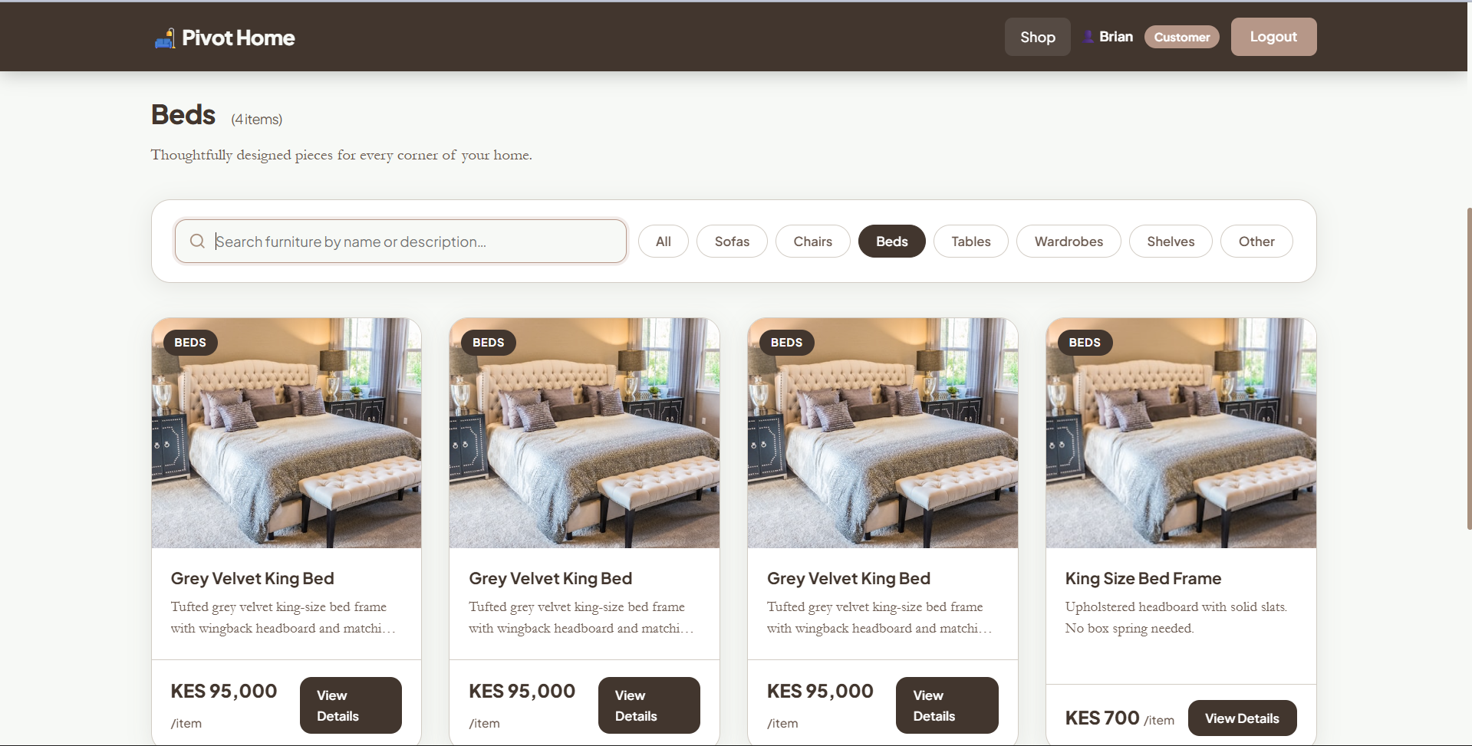

Fig 5: Dynamic User Input Handling

My Reflection(Week 3)
Frontend and backend interact by JavaScript running in the browser sends requests to PHP files on the server. PHP processes those requests, queries MySQL, and returns data which JavaScript then uses to update the page. Database connection matters because without the mysqli connection in db .php no page in Pivot Home can display products, validate login credentials, or process orders.
The purpose of validation is to ensure one does not submit invalid data.Technologies used are the HTML and CSS for the structure of the interface while PHP processes user requests server-side.

WEEK 4

Server-Side Components and Backend Development Foundations
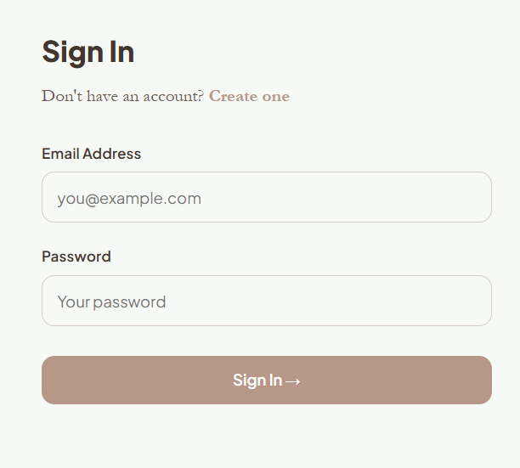
Fig 4.1 Login form
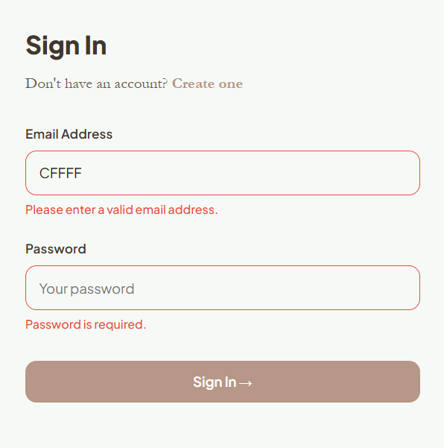
Fig 4.2 Form Validation
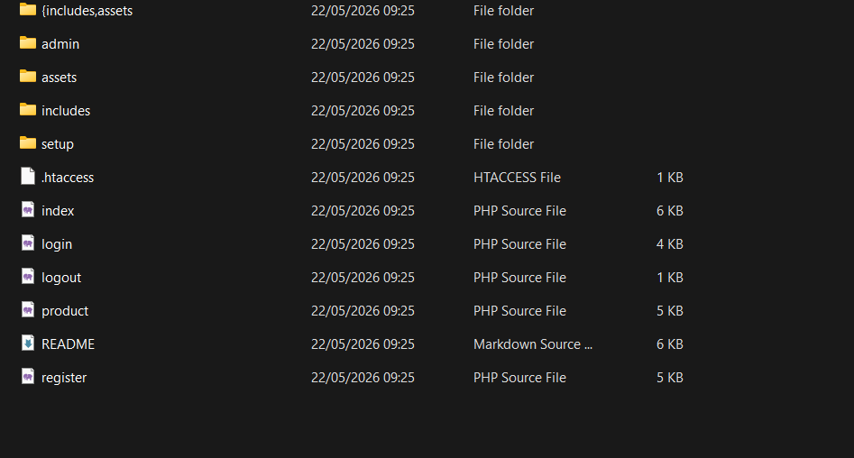
Fig 4.3 Folder structure
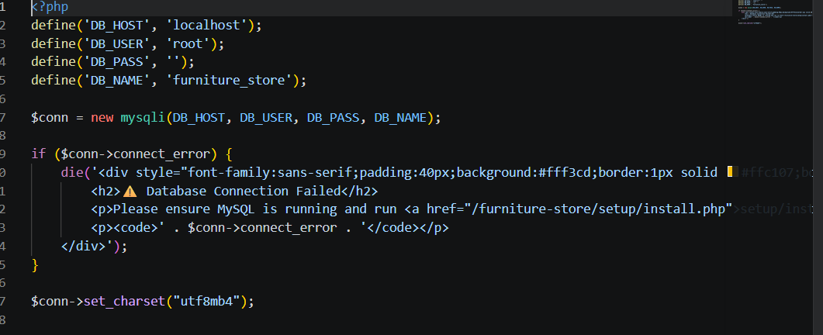
Fig 4.4 Database connection
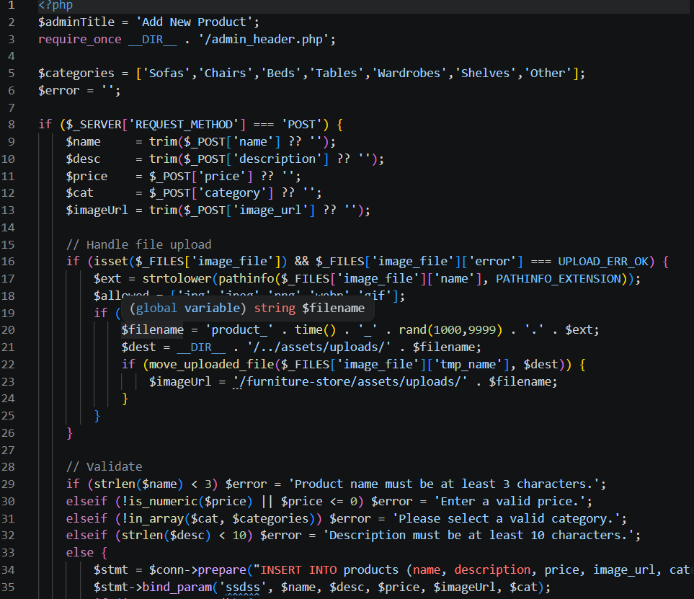
Fig 4.5 Code Snippets

WEEK 5

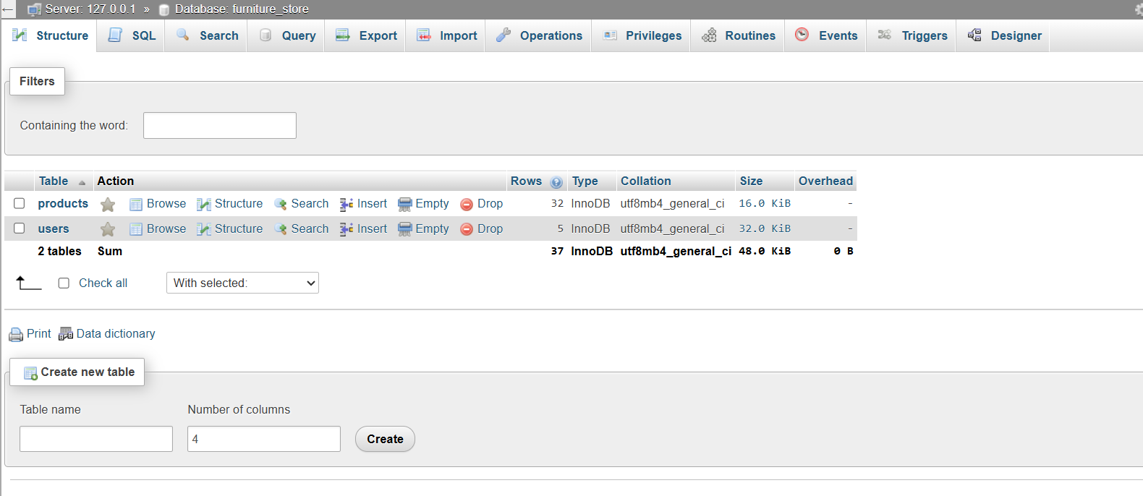

Fig 5.1 Database screenshot

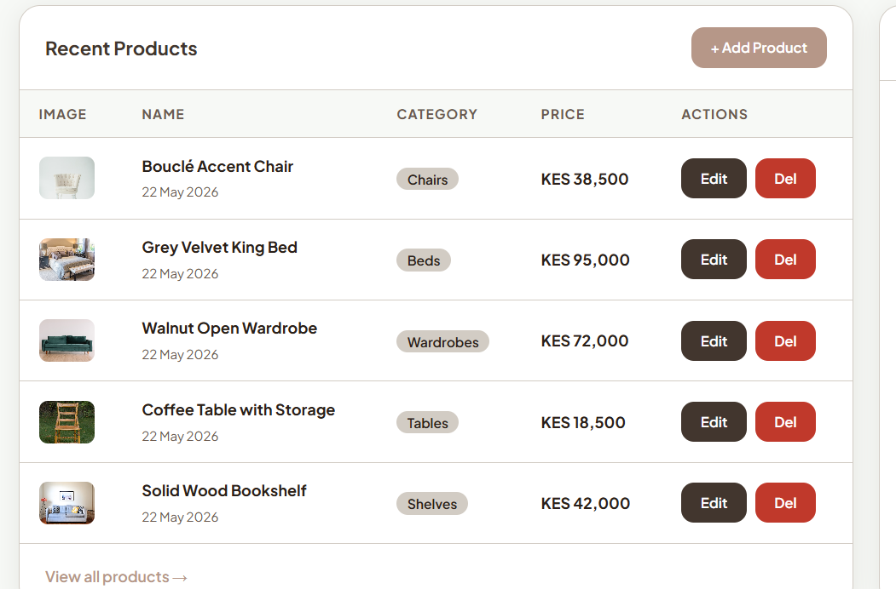

Fig 5.2 Crud Operations

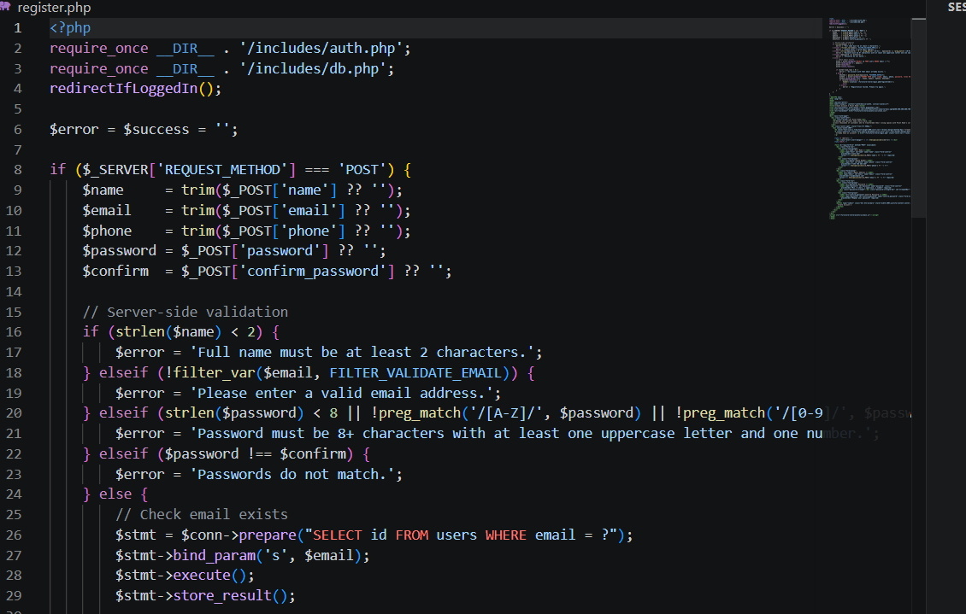

Fig 5.3 Login database intergration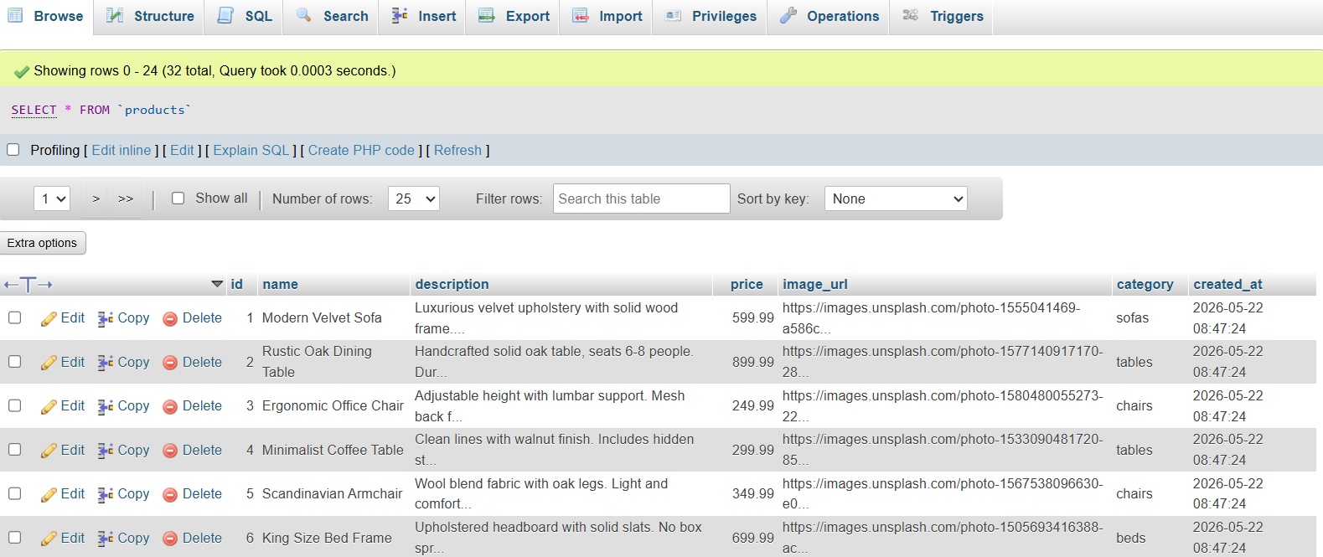

Fig 5.4 SQL complete Query

